RULES

Races will be governed by the rules as defined in The Racing Rules of Sailing, the Prescriptions of the RYA and these Sailing Instructions.

References in this document to rules are to the World Sailing Racing Rules of Sailing 2021-24.

sailing.org/tools/documents/WSRRS20212024FinalwithChgsandCorrecns201113-[26798].pdf

Notices to Competitors

Notices to competitors will be posted on the Cruiser Racing WhatApp group.

Entries & Declarations

All competitors must sign on before a race and text their Finishing declarations to the Cruiser race WhatsApp group. Competitors may sign on by emailing cruisers@tudorsailing.org.uk or by VHF Channel 37

A boat that does not finish or retires after finishing shall notify the Race Officer or Cruiser Racing Captain as soon as possible.

Race Duty Compensation – Helms who are doing Race Officer duties in a series may claim compensation points for that race. To do this they must sign on with their boat details and must write ‘Duty’ in the ‘Finish Time/DNF’ column.

The minimum number of boats forming a fleet is 2.

Changes to Sailing Instructions

Any change to the sailing instructions will be posted at least 1 hour before the scheduled time of the first warning signal on the day it will take effect.

Schedule of Races

A schedule of races is published by the Captains Committee at the start of the season and is referred to as the ‘Sailing Calendar’.

The scheduled time of the warning signal for the first race each day is five minutes prior to the published start time in the sailing calendar.

CLASS FLAGS & HANDICAP SYSTEM

The warning flag for each race with be the international code flag ‘C’

It is normal practice to fly the Class Flag ‘C’ in place of the Red Ensign onboard competing vessels during racing, removing it after the race or if you retire. This is NOT compulsory and penalties will NOT be imposed if the Class Flag is not flown.

If multiple fleets are racing (i.e. Dinghies & Cruisers) the class flag will be flown beneath any flag signal to denote which class the instruction relates to.

COURSE

For a club line start, the course to be sailed will be selected from the list of Cruiser Courses in Appendix A of this document. The course letter will be broadcast on VHF Channel M1 (37) 30 minutes before the race is due to start.

Courses for Committee Boat starts will be displayed on the side of the committee boat or be communicated from the committee boat.

Start LinE & FINISH LINE

The starts will be from the TSC club line or the club committee boat or the start line designated in the Race Instructions for the Race in question.

The Club Start Line is the extension of a line through the centres of two triangles in front of the clubhouse.

For Club Line starts there is an outer distance mark at the Eastern end of the line; a yellow ball on a post. Boats must pass to the West of this mark when starting and finishing. (Note that the outer distance mark may not lie exactly on the line).

Committee Boat Line: The line will be between (a) a mast or staff flying the Club Burgee or an Orange Flag on the committee boat and (b) an outer distance mark. An inner distance mark may be laid in which case boats must pass between the outer and inner distance marks when starting.

the Start

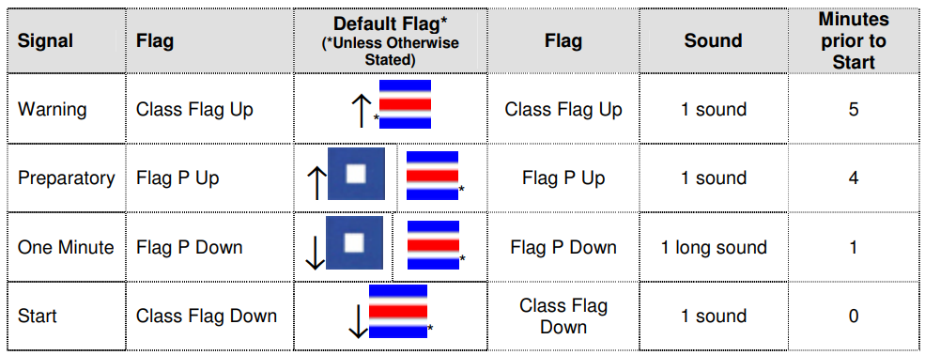
Races will be started using a 5 minute sequence.

Boats whose warning signal has not yet been made shall avoid the starting area during the starting sequences for other fleets where applicable

The race may be postponed at the discretion of the race officer at any point prior to or during the start sequence.

A postponement maybe initiated for any reason; typical reasons include change in wind strength or direction, patrol boat not on station, marks not in place, a large vessel approaching the sailing area, or an error with the signal sequence.

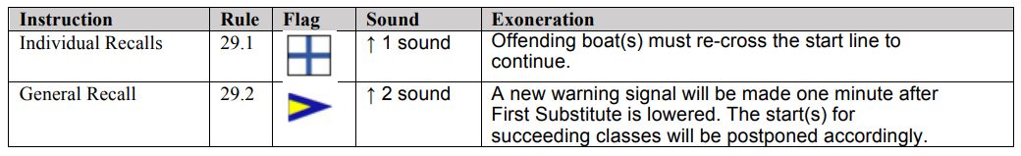
A postponement period is ended by lowering the answering pennant, accompanied by one short sound signal. There shall be a 1 minute period before the start sequence is initiated. For all on water starts the postponement will be broadcast on VHF Channel M1 (37)

The following rules and signals shall be used to manage recalls:

THE FINISH

The finish line will be the LINE defined in instruction 8 or as designated in the Sailing Instructions for the Race in question. Boats must pass to the West of the outer distance mark when finishing.

New Finish Line: If a race has started but in the opinion of the Race Officer, boats are unlikely to be able to complete their current lap, the Race Officer may finish the race at a new finish line, for example when the boats round a specific mark on a specific lap. Any such change to the finish line will be will be broadcast on VHF Channel M1 (37)

Time Limit

Will be as designated in the Sailing Instructions for the Race in question. If no boat finishes within the time limit, the race officer shall abandon the race.

PROTESTS AND REQUESTS FOR REDRESS

The Exoneration Penalty and the Advisory Hearing and RYA Arbitration procedures of the RYA Rules Disputes Procedures will be available. Decisions from RYA Arbitration can be referred to a protest committee but cannot be reopened or appealed. See Official Notice Board for details.

Protest forms are available on request from the Race Officer and are stored in the race box at Tudor Sailing Club.

Protests or requests for redress shall be delivered to the race officer within the appropriate time limit.

The protest time limit is 90 minutes after the last boat has finished the last race of the day. This time limit can be extended at the discretion of the Race Committee.

SCORING

Scoring will be in accordance with Appendix A (Low Point System). Rule A9 will apply. Two races shall be completed to constitute a valid series.

A change of helm or handicap configuration will be treated as a separate entry in the series for scoring.

Race Duty Compensation: Points are calculated as the average of the scores for all other races in the series

The number of races to count in a series will be as follows:
Races sailed: N 1 2 3 4 5 6 7 etc
No. to count: N/2 raised to next highest whole number 1 2 2 3 3 4 4 etc

PRIZES

Prizes will be awarded for 1st, 2nd and 3rd places in club series. For Trophy races only first place will usually be awarded.

RISK STATEMENT

Rule 3 of the Racing Rules of Sailing states: “The responsibility for a boat’s decision to participate in a race or to continue racing is hers alone.”

A compass must be carried by all boats competing in races where all or part of the course is outside of Langstone harbour.

Helping Those in Danger - A boat or competitor shall give all possible help to any person or vessel in danger.

Sailing is by its nature an unpredictable sport and therefore involves an element of risk. By taking part in the event, each competitor agrees and acknowledges that:
- They are aware of the inherent element of risk involved in the sport and accept responsibility for the exposure of themselves, their crew and their boat to such inherent risk whilst taking part in the event.
- They are responsible for the safety of themselves, their crew, their boat and their other property whether afloat or ashore.
- They accept responsibility for any injury, damage or loss to the extent caused by their own actions or omissions.
- Their boat is in good order, equipped to sail in the event and they are fit to participate.
- Sailors will wear appropriate personal buoyancy as set out in the club ‘Personal Buoyancy Policy’
- The provision of a race management team, patrol boats, umpires and other officials and volunteers by the organiser does not relieve them of their own responsibilities.

INSURANCE

Each participating boat shall be insured with valid third-party liability insurance with a minimum cover of £3,000,000 per event or the equivalent.

RIGHTS TO USE NAME AND LIKENESS

By participating in this event, competitors automatically grant to the organising authority and the event sponsors the right, in perpetuity, to make, use, and show, at their discretion, any photography, audio and video recordings, and other reproductions of them made at the venue or on the water from the time of their arrival at the venue, until their final departure, without compensation.

Photography and social media. From time-to-time members of the club may take photos and video in the public areas of the club and on the water. The club also occasionally posts photographs on the club website and on social media.

Opting out of photography. The club operates an opt-out policy for photography. Parents and carers are asked to explicitly opt out if they do not want their children to be photographed at organised events. Club members are explicitly asked not to “tag” photographs of children in social media unless they have the explicit permission of the family concerned. Parents and spectators should be prepared to identify themselves if requested and state their purpose for photography/filming. If the Club publishes images of children, no identifying information other than names will be included and names will only be used with parental permission. Any concerns about inappropriate or intrusive photography or the inappropriate use of images should be reported to the Club Welfare Officer

SPORTSMANSHIP & THE RULES

Competitors in the sport of sailing are governed by a body of rules that they are expected to follow and enforce. A fundamental principle of sportsmanship is that when competitors break a rule they will promptly take a penalty, which may be to retire

engines

All engines must be turned off at least 4 minutes before the race start time.

If you have to use your engine for safety reasons (e.g. to clear a shipping channel or to avoid a collision) then you must note down the length of time the engine was running for and then declare it, with your start and finish times, at the end of the race, this will then be added to your elapsed time. No distance advantage may be gained whilst using an engine, it is only to be used for safety reasons

Appendix A – Cruiser Short Courses

